**Your text here**

**Your text here**

**Your text here**

**Your text here**



**Wafer Fault Prediction Using**

**Machine Learning**

**fffff**

This project uses machine learning to predict faults in semiconductor wafers, enhancing quality and precision in manufacturing. By analyzing sensor data and clustering, it identifies potential faults in real-time, reducing waste. The system leverages cloud infrastructure for scalable and efficient deployment.

**Author: Vimalathas Vithusan**

**Date: March 2025**

**Version: 1.0**

**GitHub:** [**https://github.com/thasvithu**](https://github.com/thasvithu)

**LinkedIn:** [**https://www.linkedin.com/in/thasvithu**](https://www.linkedin.com/in/thasvithu)



**Table of Contents**

**Problem Statement** 2

**All about wafer** 2

**Architecture** 4

**Data Description** 4

# **Problem Statement**

In semiconductor manufacturing, defects in wafers can lead to faulty microchips, causing **high production costs and material waste**. Detecting these defects early is challenging due to the **complexity of the fabrication process** and the **large volume of sensor data** generated.

This project aims to develop a **machine learning model** that predicts whether a wafer is **faulty or non-faulty** based on sensor data collected during manufacturing. By automating fault detection, the project helps improve **quality control, reduce waste, and enhance production efficiency**.

# **All about wafer**

#### **What is a Wafer?**

A wafer is a thin, flat slice of semiconductor material, usually **silicon**, used to create microchips and electronic components like **processors** and **sensors**.

#### **Where is the Data Collected From?**

Data comes from sensors on manufacturing machines that track temperature, pressure, and chemicals during the wafer production process. This helps ensure everything is running smoothly and identifies defects early.

#### **Uses of Wafer**

Wafers are used to make **microchips**, **integrated circuits (ICs)**, **solar panels**, and **LEDs**, powering everything from smartphones to medical devices.

#### **What Does a Wafer Contain?**

* **Substrate**: The base of the wafer, usually silicon.
* **Circuit Layers**: Layers of electronic circuits built on the wafer.
* **Protective Coating**: A layer to protect the circuits from damage.

#### **What Are the Boxes on the Wafer?**

The small square boxes are called **dies**. Each die is a small microchip or integrated circuit, and a single wafer can have hundreds or thousands of them.

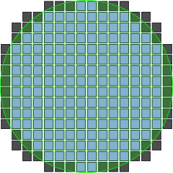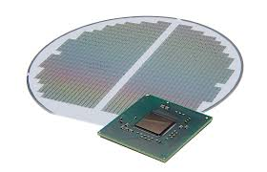

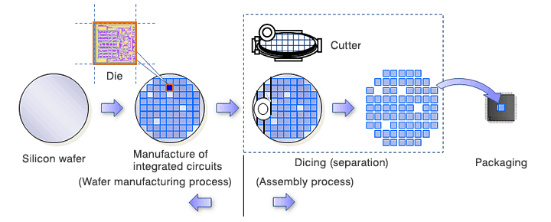

[More info : https://en.wikipedia.org/wiki/Wafer_(electronics)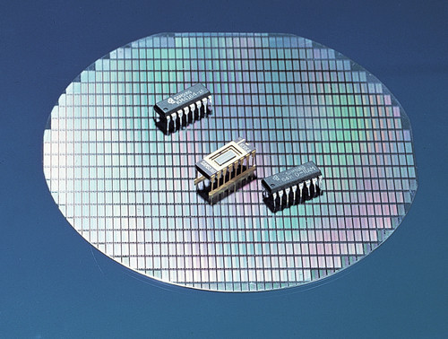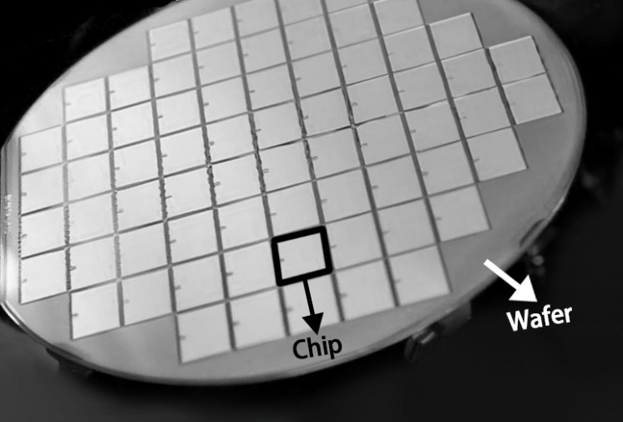](https://en.wikipedia.org/wiki/Wafer_(electronics))

# **Architecture**

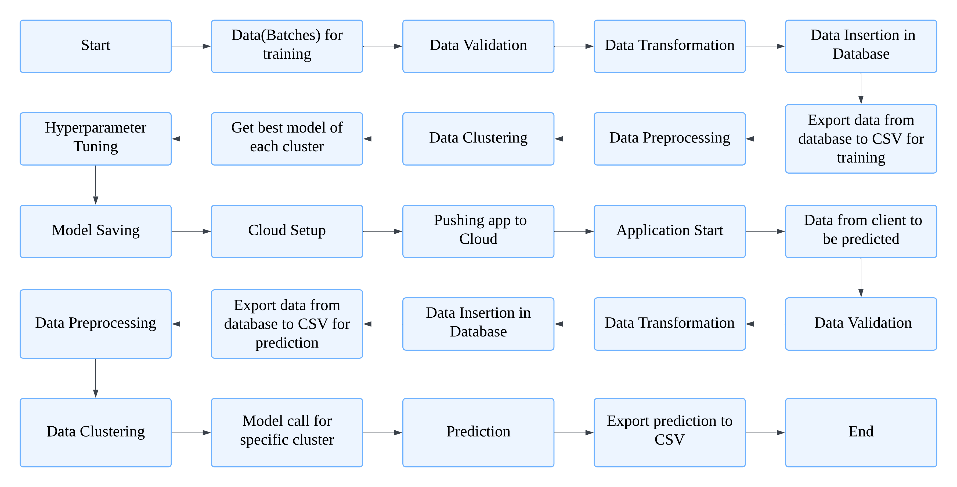

# **Data Description**